DATA ANALYTICS WITH R, EXCEL AND TABLAEU ASSIGNMENT Excel Analytics 28.1

ANSWERS

5. Problem Statement

1. You are expected to submit the steps you followed for doing all the below subtasks.

  - Use the “Sales_Data.xml” file.

- Access the “xml” file in excel and save it to a comma delimited “csv” file.

- Make all the rows where “attractiveness<6” to

Background color=red,font =8,font-type=italic.

Ans
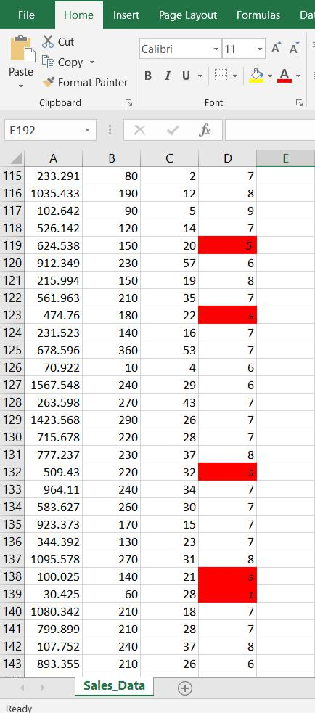

Hide all the rows by grouping where “attractiveness<6” Ans
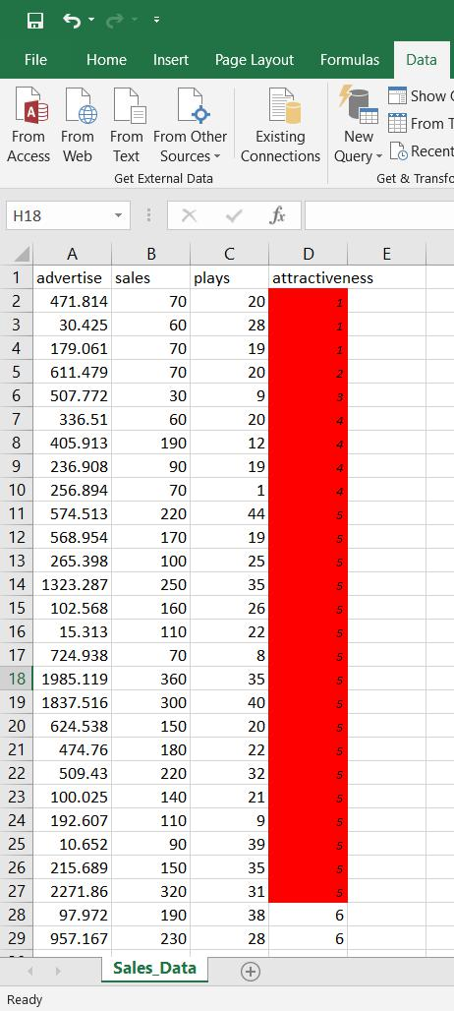
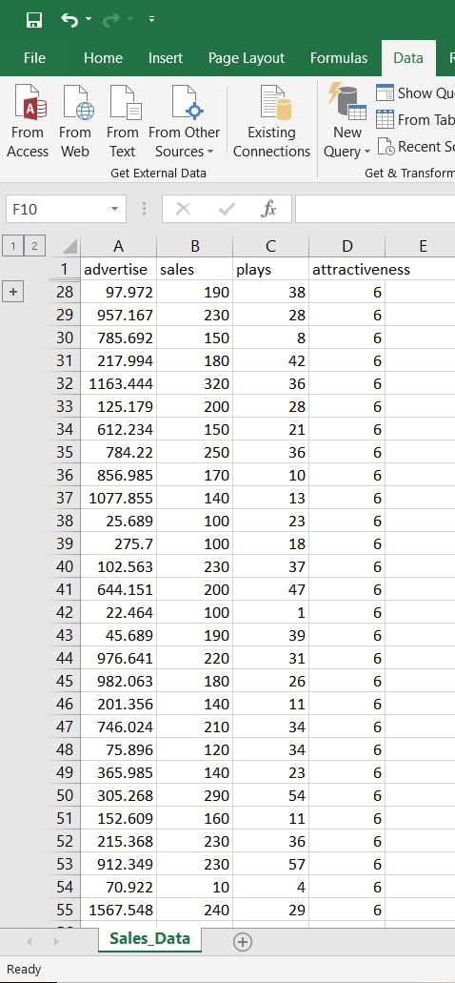
Prepend C before the number in attractiveness.

Ans:
